**CMPE-272 Enterprise Software Platforms**

**Lab-1**

**Name:** **Vedant Tushar Mehta** **Student ID:** **018207436**

1. **Description**: This screenshot shows the Whitelabel Error Page at *localhost:8080*.

**Purpose**: Confirms that the server is running, but the root URL (*localhost:8080*) has no mapped route.

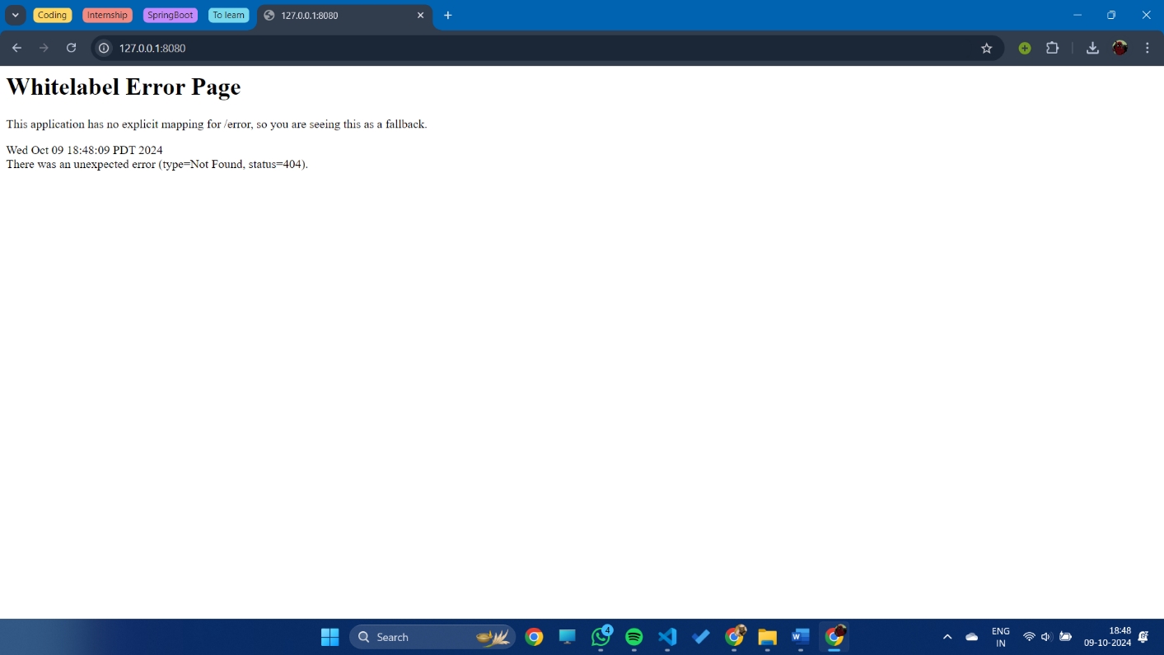

1. **Description**: The *GET* request at *127.0.0.1/greeting* returns JSON with id 1 and content: "Hello, World!".

**Purpose**: Tests the default functionality of the /greeting endpoint, which provides a greeting message with the default name “World.”

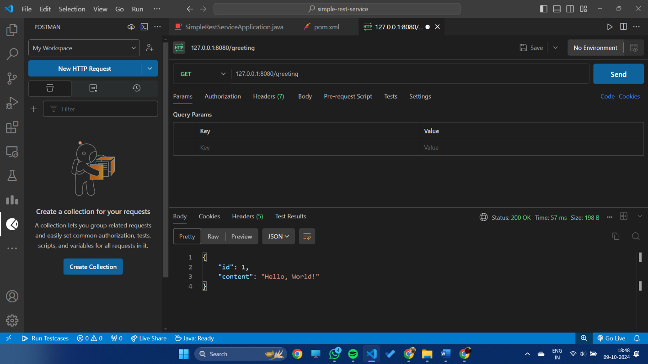

1. **Description**: The *GET* request at *127.0.0.1/greeting?name=John* returns JSON with id: 2 and content: "Hello, John!".

**Purpose**: Tests the /greeting endpoint with a custom name parameter.

